**Database System**

**LAB Practical 6**

**Q1: Create a table Emp with attributes ename, ecity, salary, enumber with following constraints: enumber is the primary key and should start with ‘E’, ecity should have default values as Delhi.**

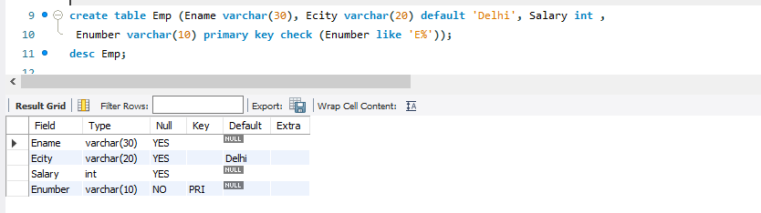

**Q2: Create another Table Department with attributes did, budget and manager_id, dname with following constraints: budget should not be less than 10000.**

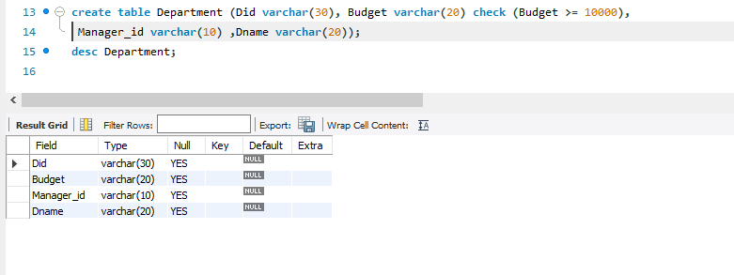

**Q3: Create another Table Works with attributes did and eid & combination of both as primary key**

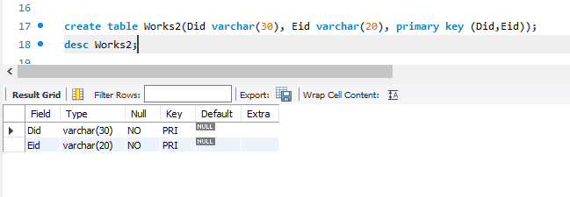

**Q4: Alter table Department and make did as the primary key.**

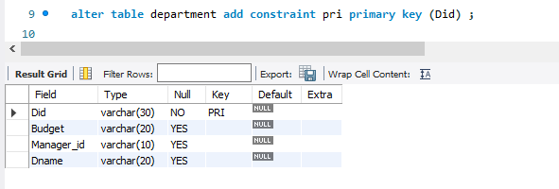

**Q5: Alter table Department and make manager_id as the foreign key.**

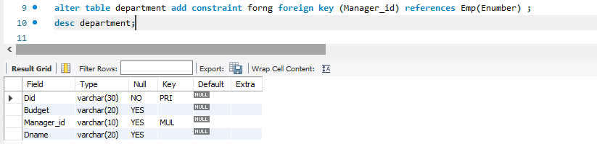

**Q6: Alter table Works and make did and eid as foreign key.**

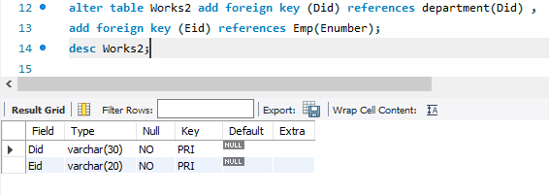

**Q7: Create table book with attributes ISBN, title, price, pid with following constraints: ISBN is the primary key, price should be >=20/<=200, title should not have null values.**

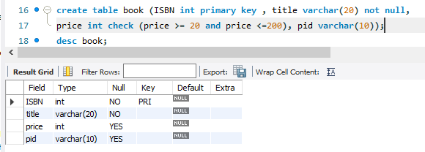

**Q8: Create table publisher with attributes pid, pname, state with following constraints: pname should not have null values; state should be either Haryana, Tamil nadu, Maharashtra.**

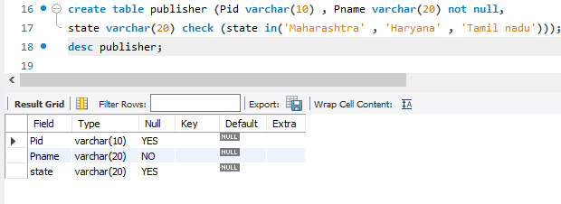

**Q9: Alter the table publisher by making pid as primary key.**

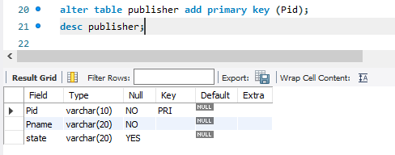

**Q10: Alter the table book by making pid as foreign key.**

